(Teacher’s Name) Fresh Schools

Hello Parents,

We are excited to introduce ourselves as (insert teacher) Room Parents this year! This year, we will be communicating with the class through our Fresh Schools App. We noticed that you are not signed up and want to request that you please sign up TODAY to avoid missing all future school communications.

You can sign up in two ways:

- You can log onto this website: https://www.freshschools.com/app/schools/providence-spring-elementary/register

OR

- Use your camera to scan this QR code and register from here:

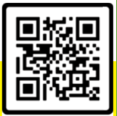

Once on the website, it is easy to register:

- Put your child’s information into the blanks;
- Put your information into the next set of blanks;
- Ensure you click “I’m not a robot” then submit

Please take the time to do this today!!

Thank you for your support of our classroom. Please contact us with any questions.

(Room Parent Names)

